SPRINT 3

Python functions
- Reusable block of code that is designed to perform a specific task and runs ONLY when called
- Can return data as a result
- Helps avoiding code repetition
- Created using ‘def’ keyword, followed by function name and parenthesis – ()
- Rules for function names: {same rules as variables}
- Must start with a letter or underscore
- Can only contain letters, numbers, and underscores
- Case sensitive

Need of functions
- Code reusability, avoids repetition
- Breaks large programs into smaller parts
- Improves readability
- Makes debugging easier
- Can return results

Return keyword
- Doesn’t print but gives the value back to the caller
- Need?
When we want to get the answer back and use it somewhere else eg, price of the food + delivery charges
- If no return statement in a function, returns None by default

Difference between Argument and Parameter
- Parameter is a variable in function definition
- Argument is the actual value we pass to that parameter while calling the function
- Function must be called with:
No. (Arguments) == No. (Parameters)
- Can call function without an argument, i.e. default parameter value like: def greet (name = ’drishti’)

Arguments:
- Keyword Arguments – can send arguments with (key = ‘value’) syntax
Keyword-only arguments mean that the argument MUST be passed with key ONLY; used with ‘*’
Eg: def greet (*, name)

- Positional arguments – when we call function with arguments without using keywords; order matters here
Positional-only arguments mean that the argument MUST be passed by position ONLY; used with ‘/’
Eg: def greet (name, /)

Both (positional and keyword) arguments can be mixed together like: func(‘drishti’, lastname=’sharma’) BUT
Positional arguments will ALWAYS come BEFORE ALL keyword arguments

Combining positional and keyword only:
- Arguments before ‘/’ are position only
- Arguments after ‘*’ are keyword only
Eg: def func(a,b,/,*,c,d) so we can use function call as:
Func(10,’arc’,c = 10, d = ‘green’)

*args and **kwargs
- *args – lets a function accept any number of positional arguments
- **kwargs – lets a function accept any number of keyword arguments(key=value)
Their need?
- *args, when we don’t know how many values will be passed to the function; concept aka arbitrary arguments
Inside the function, *args always collects the positional arguments into a tuple
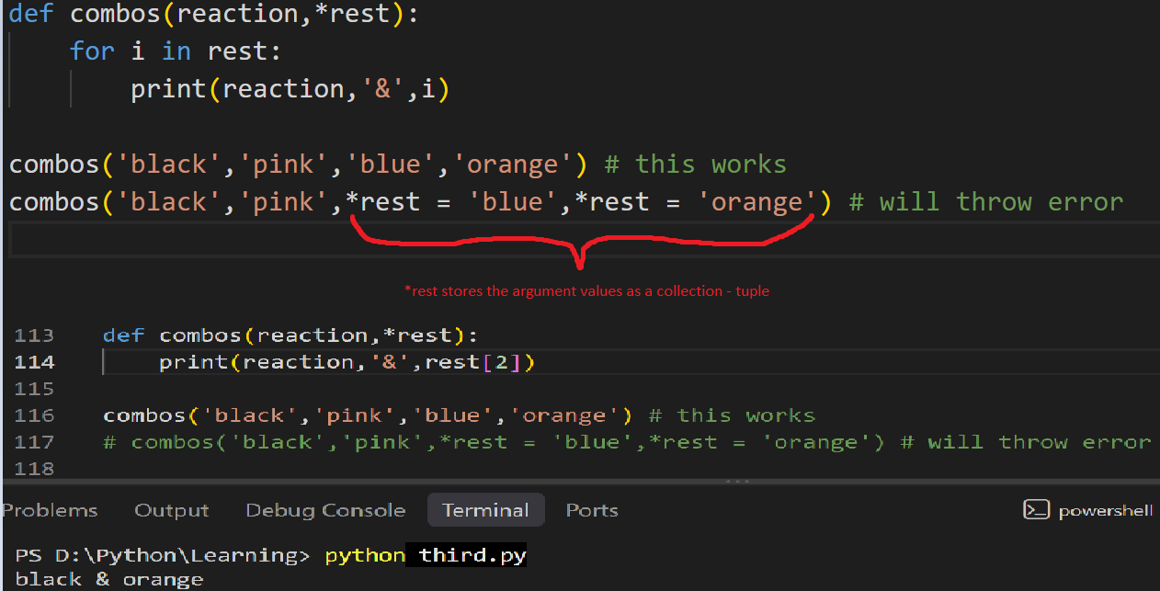

- **kwargs, when we don’t know how many named values will be passed; concept aka arbitrary keyword arguments
Inside the function, **kwargs always collects the keyword arguments into a dictionary (why? Because being stores in key=value pairs)

Unpacking arguments
- Taking a collection and opening it up to separate arguments when calling a function
- ‘*’ – used to unpack a list/tuple
- ‘**’ – used to unpack a dictionary
- Basically takes the values from a list/tuple/dict and pass them as separate arguments

Scope
- Area / part of the program where a variable is accessible and can be used
- Determines where a variable exists and where we can access it and can use it
- Local scope –
- variable created inside a function belongs to the local scope of the function, and can be only used inside that function
- variable accessible for any function inside that function where the variable is defined
- Global scope –
- Variable created in main body of the python code
- Available from any scope, global and local
- Global keyword – lets a function change the original value defined outside the function instead of creating a new variable
- Nonlocal keyword – used when we have a function inside another function and the inner function needs to change the value of the variable belonging to the outer function

- LEGB Rule – order in which python look up variable names and searches them in this order:
- Local – checks inside current function
- Enclosing – when variable isn’t found inside the inner function, python looks for it in its parent function
- Global – if still not found, checks the global level of the program
- Built-in – finally, checks the python’s built in names like print, len, sum etc

Decorators
- A function that adds some extra work/behaviour to another function without changing the original function, like wrapping a function with extra functionality
- Need?
When we want to apply the same extra behaviour to multiple functions without putting that extra code inside each function
- Things to remember
- Decorator receives og function as a parameter
- Wrapper contains the extra behaviour
- Call og function inside wrapper
- Return wrapper

Lambda
- Small, single line function that doesn’t have a name
- Can take multiple arguments, but can perform a single expression
- When defining a normal def function feels unnecessarily long
- Syntax: lambda arguments : expression
- Used when:
- We need a function temporarily and don’t want to define it separately
- With funcs like map(), filter(), sorted()
Map() – applies same function to every item in a collection
Filter() – keeps only the items for which condition is True
Sorted() – returns a new sorted list

Recursion
- When a function calls itself
- Loop repeats code by using a loop statement, recursion repeats code by a function calling itself
- Has 2 parts:
- Base case – condition that stops the recursion; without base case, function would call itself forever, causing stack overflow error
- Recursive case – function calling itself with modified argument
- Python has a recursion limit of 1000 recursive calls

Generators
- Functions that can pause and resume their execution
- Gives one value at a time instead of giving all values at once
- Uses ‘yield’ which pauses the function after giving a value, when we ask for next value if continues from where it stopped
- Need?
- Saves memory
- Good for large amounts of data
- Doesn’t create all values at once
- Used when we need to product the values dynamically

